App: Pixelate: Phase #1

Date: Feb 27th, 2023  
Domain: <https://pixelate.brickmmo.com>

GitHub: <https://github.com/codeadamca/brickmmo-pixelate>

# Application Purpose:

This application will convert a provided image to a set of instructions to recreate the image using LEGO™ bricks.

The end result will be instructions to create something similar to the LEGO™ World Map (<https://www.lego.com/en-us/product/world-map-31203>):

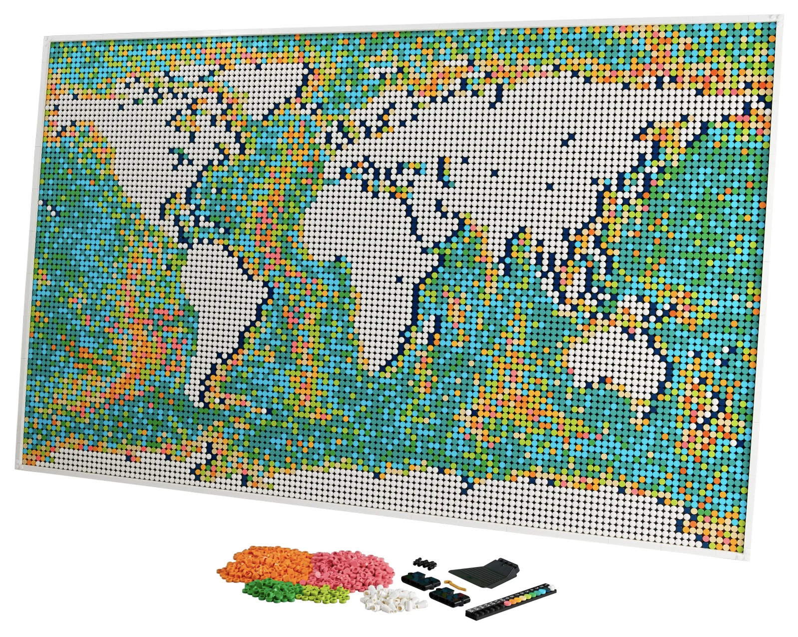

# Front-End:

Front end facing application will include the following features:

* A place to upload an image, specify width and height, and convert the image to a series of LEGO™ bricks (similar to <https://legoimage.com/> or <https://mingze-gao.com/apps/legao/>)
* Resulting image can be downloaded as a JPG
* Result will also display a list of required bricks and quantity, should be styled like typical LEGO™ instructions
* Results will also display a copyable matrix of colours
* Instructions can be downloaded as a PDF
* Each submission will be saved to the database

Instructions will look similar to this:

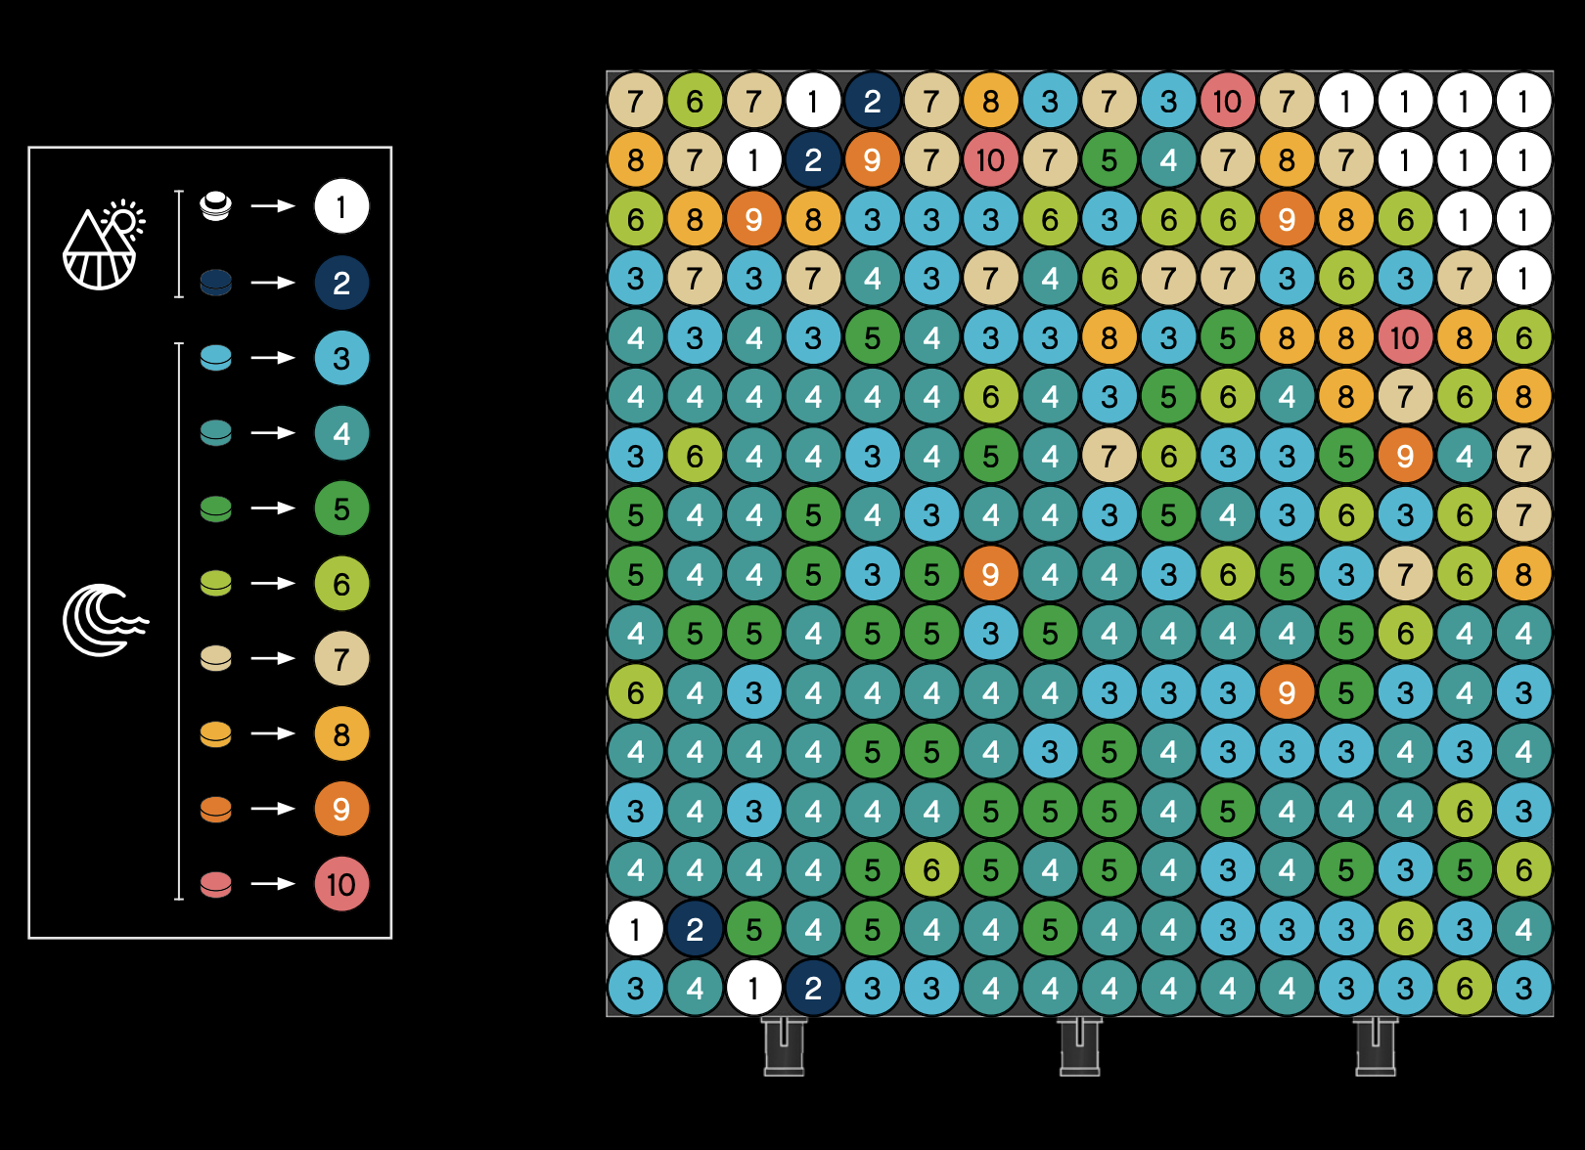

Taken from the World Map LEGO™ instructions:  
<https://www.lego.com/cdn/product-assets/product.bi.core.pdf/6372756.pdf>

Sample conversion

 

# Back-End:

Application will include a control panel to achieve the following:

* Login to control panel
* Add, edit, and delete converted images
* View instructions
* Export instructions to PDF

# API:

Application API will include the following API calls:

| **Method** | **Endpoint** | **Description** | |
| --- | --- | --- | --- |
| POST | /api/convert | Converts a specified image to a matrix of LEGO ™ colours.  **Parameters:** image (required): posted JPG, PNG, or GIF width (required): number of studs wide heigh (required)t: number of studs high  format: format to return data in, default is "json"but also accepts "jgp"  **Returns:**  A matrix of colours for each LEGO ™ brick or a JPG format image. | |